Q1) --1. GROUP BY with WHERE - Orders by Year and Quarter

---Display, order year, quarter, order count, avg freight cost only for those orders where freight cost > 100

Query:

select * from orders ---#order_id, order_date, avg_freight

select * from order_details -- #quantity,order_id

select extract(year from orders.order_date) as order_year, extract(quarter from orders.order_date), avg(orders.freight) as avg_freight, count(*) as order_count from orders inner join order_details on orders.order_id = order_details.order_id where freight> 100 group by 2,1 order by 1,2

Output:

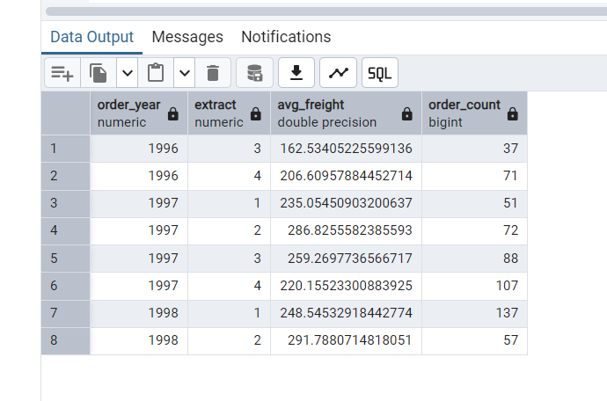

Q2) ---2. GROUP BY with HAVING - High Volume Ship Regions

---Display, ship region, no of orders in each region, min and max freight cost

---Filter regions where no of orders >= 5

Query:

SELECT ship_region, COUNT(*)AS No_of_orders,MIN(freight) AS freight_min_cost, MAX(freight) AS freight_max_cost

FROM orders GROUP BY ship_region

HAVING COUNT(*) >= 5

ORDER BY ship_region

Output:

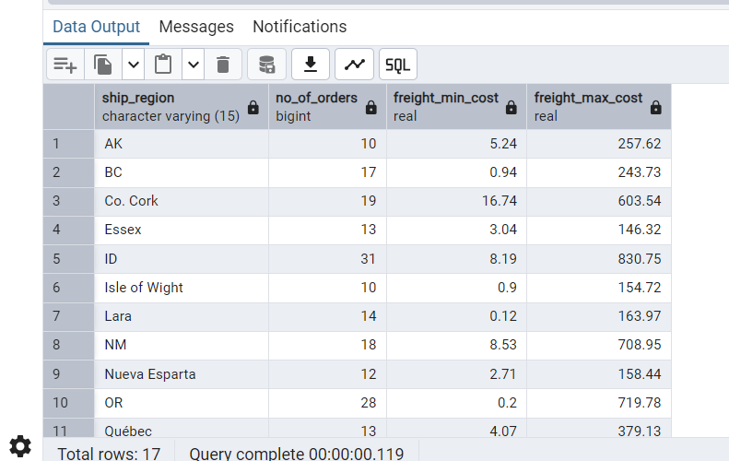

Q3) Get all title designations across employees and customers ( Try UNION & UNION ALL)

Query:

SELECT title FROM employees UNION

SELECT contact_title FROM customers

ORDER BY title;

Output:

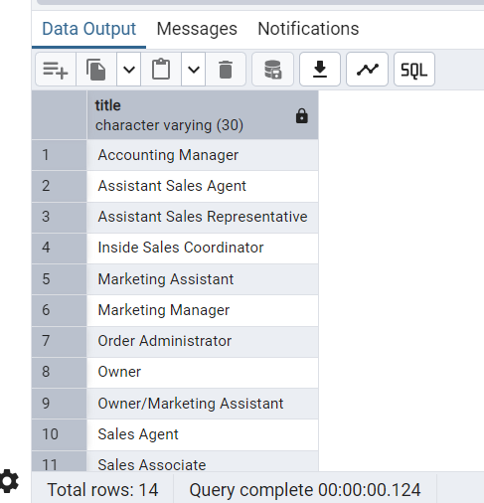

Query:

SELECT title FROM employees UNION ALL

SELECT contact_title FROM customers

ORDER BY title;

Output:

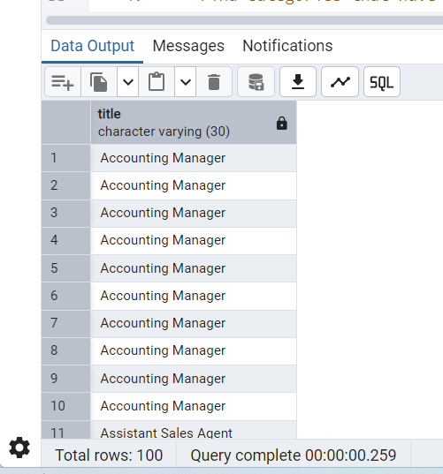

Q4) --4.Find categories that have both discontinued and in-stock products

--(Display category_id, instock means units_in_stock > 0, Intersect)

Query:

SELECT CATEGORY_ID FROM PRODUCTS WHERE DISCONTINUED = 1

INTERSECT

SELECT CATEGORY_ID FROM PRODUCTS WHERE UNITS_IN_STOCK > 0

ORDER BY CATEGORY_ID;

Output:

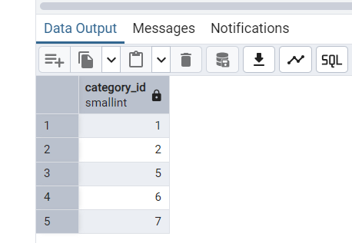

5) Find orders that have no discounted items (Display the order_id, EXCEPT)

Query:

SELECT DISTINCT order_id FROM order_details

EXCEPT SELECT DISTINCT order_id FROM order_details WHERE discount > 0

ORDER BY order_id;

Output:

